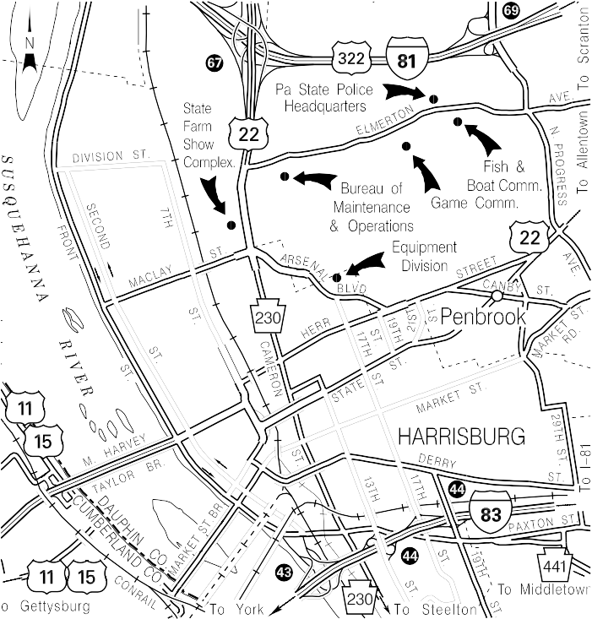
Fleet Management Building - ( Equipment Division)
17th & Arsenal Blvd.
Harrisburg, PA 17120
Phone (171) 787-2110

